Assignment 3

| Assignment Date | 07 October 2022 |
| --- | --- |
| Student Name | M. Sanjay Aravindh |
| Student Roll Number | 311019104077 |
| Maximum Marks | 2 Marks |

# Question 1:

Create a bucket in IBM object storage.

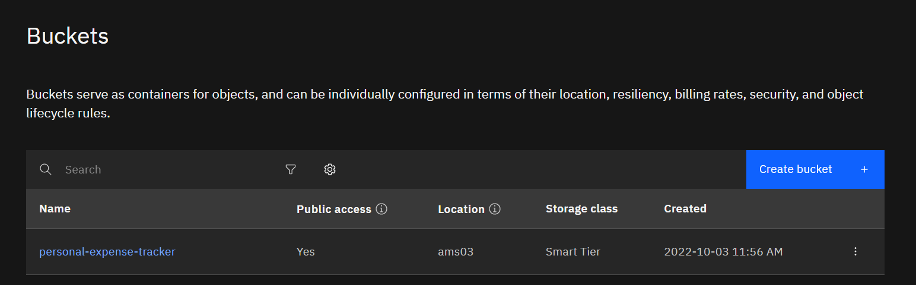

**Question 2:**

Upload any 5 images to IBM object storage and make it public. Write HTML code to displaying all the 5 images

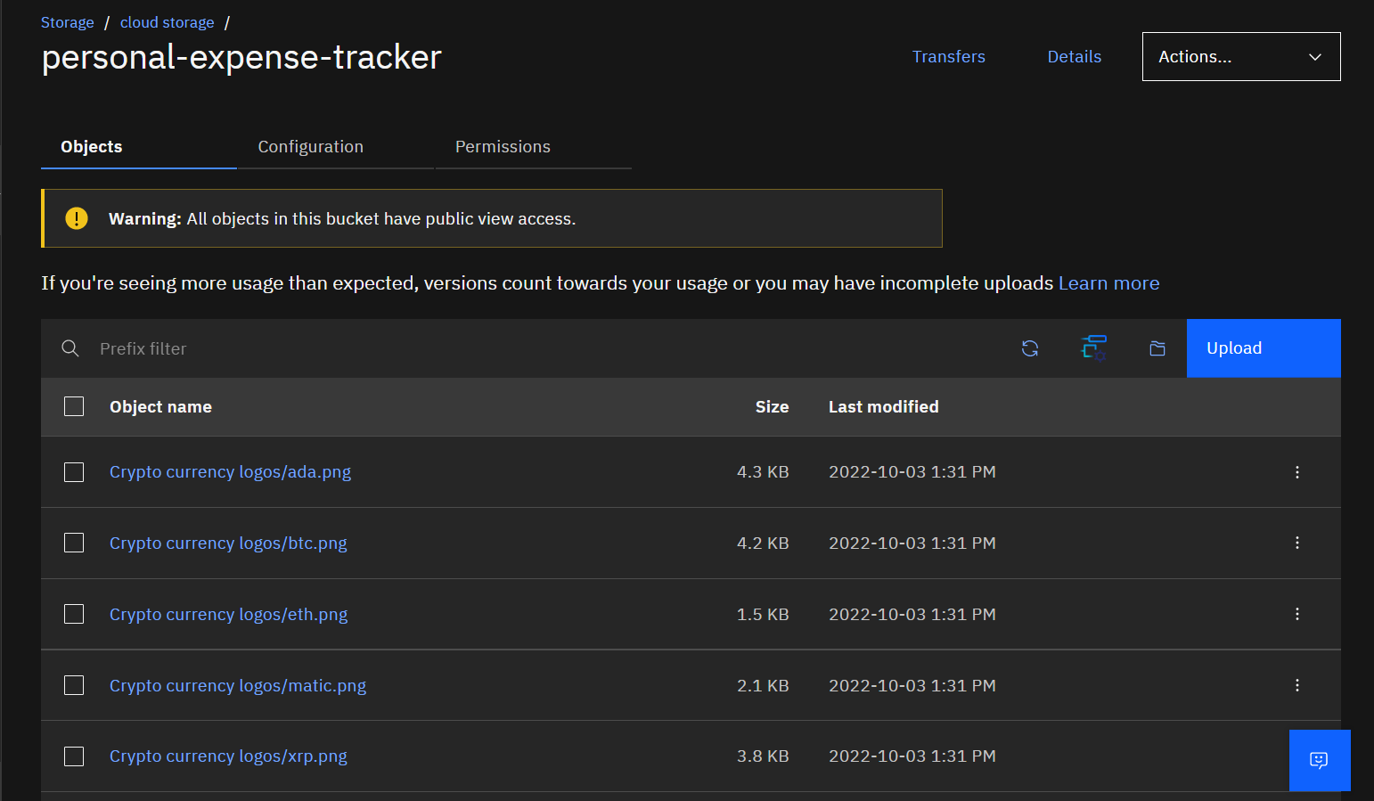

HTML code for displaying images in cloud





HTML Output for displaying images from IBM cloud storage:

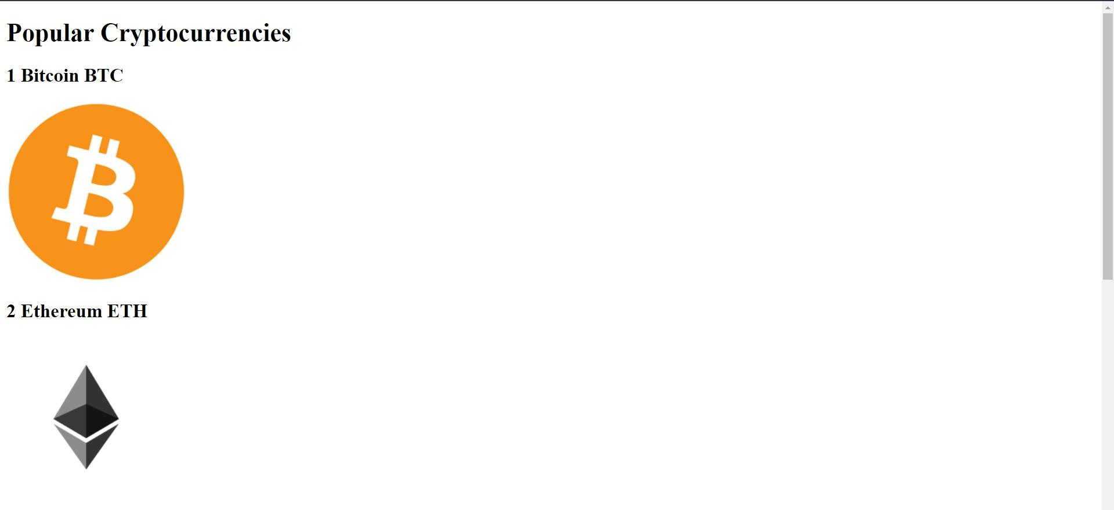

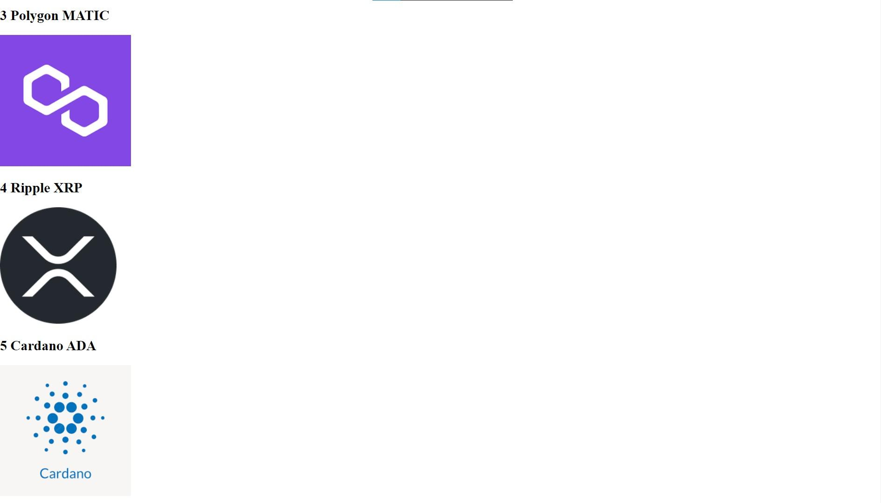

**Question 3:**

Upload a CSS page to the object storage and use the same page in your HTML code.

HTML code with CSS ﬁle present in IBM cloud storage:





HTML code output:

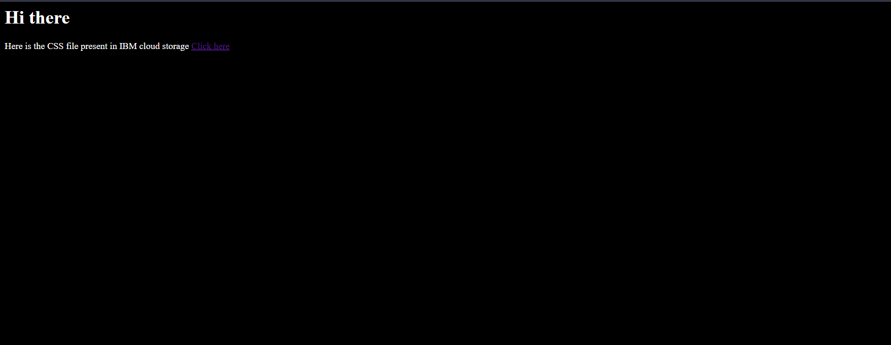

CSS ﬁle in Cloud object storage

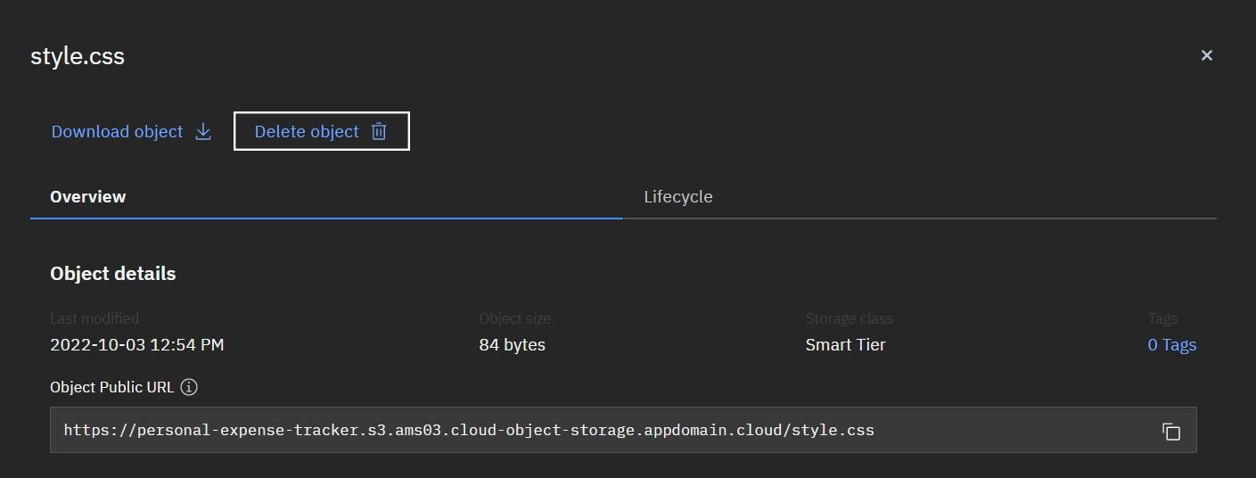

**Question 4:**

Design a chatbot using IBM Watson assistant for hospitals. Ex: User comes with a query to know the branches for that hospital in your city. Submit the web URL of that chat bot as an assignment.

**Web URL of chat box:**

[https:*/* web-chat.global.assistant.watson.appdomain.cloud/preview.html?ba](https://web-chat.global.assistant.watson.appdomain.cloud/preview.html?backgroundImageURL=https%3A%2F%2Fjp-tok.assistant.watson.cloud.ibm.com%2Fpublic%2Fimages%2Fupx-f3a1f015-5572-4204-96b6-7c25f885ddc6%3A%3A156bcb72-665e-46b3-872e-a17217657433&integrationID=d2b53d34-6e0e-4d81-b157-ae1023cd641a&region=jp-tok&serviceInstanceID=f3a1f015-5572-4204-96b6-7c25f885ddc6) [ckgroundImageURL=https%3A%2F%2Fjp-tok.assistant.watson.cloud.ibm.co](https://web-chat.global.assistant.watson.appdomain.cloud/preview.html?backgroundImageURL=https%3A%2F%2Fjp-tok.assistant.watson.cloud.ibm.com%2Fpublic%2Fimages%2Fupx-f3a1f015-5572-4204-96b6-7c25f885ddc6%3A%3A156bcb72-665e-46b3-872e-a17217657433&integrationID=d2b53d34-6e0e-4d81-b157-ae1023cd641a&region=jp-tok&serviceInstanceID=f3a1f015-5572-4204-96b6-7c25f885ddc6) [m%2Fpublic%2Fimages%2Fupx-f3a1f015-5572-4204-96b6-7c25f885ddc6](https://web-chat.global.assistant.watson.appdomain.cloud/preview.html?backgroundImageURL=https%3A%2F%2Fjp-tok.assistant.watson.cloud.ibm.com%2Fpublic%2Fimages%2Fupx-f3a1f015-5572-4204-96b6-7c25f885ddc6%3A%3A156bcb72-665e-46b3-872e-a17217657433&integrationID=d2b53d34-6e0e-4d81-b157-ae1023cd641a&region=jp-tok&serviceInstanceID=f3a1f015-5572-4204-96b6-7c25f885ddc6)

[%3A%3A156bcb72-665e-46b3-872e-a17217657433&integrationID=d2b5](https://web-chat.global.assistant.watson.appdomain.cloud/preview.html?backgroundImageURL=https%3A%2F%2Fjp-tok.assistant.watson.cloud.ibm.com%2Fpublic%2Fimages%2Fupx-f3a1f015-5572-4204-96b6-7c25f885ddc6%3A%3A156bcb72-665e-46b3-872e-a17217657433&integrationID=d2b53d34-6e0e-4d81-b157-ae1023cd641a&region=jp-tok&serviceInstanceID=f3a1f015-5572-4204-96b6-7c25f885ddc6) [3d34-6e0e-4d81-b157-ae1023cd641a&region=jp-tok&serviceInstanceID=f](https://web-chat.global.assistant.watson.appdomain.cloud/preview.html?backgroundImageURL=https%3A%2F%2Fjp-tok.assistant.watson.cloud.ibm.com%2Fpublic%2Fimages%2Fupx-f3a1f015-5572-4204-96b6-7c25f885ddc6%3A%3A156bcb72-665e-46b3-872e-a17217657433&integrationID=d2b53d34-6e0e-4d81-b157-ae1023cd641a&region=jp-tok&serviceInstanceID=f3a1f015-5572-4204-96b6-7c25f885ddc6) [3a1f015-5572-4204-96b6-7c25f885ddc6](https://web-chat.global.assistant.watson.appdomain.cloud/preview.html?backgroundImageURL=https%3A%2F%2Fjp-tok.assistant.watson.cloud.ibm.com%2Fpublic%2Fimages%2Fupx-f3a1f015-5572-4204-96b6-7c25f885ddc6%3A%3A156bcb72-665e-46b3-872e-a17217657433&integrationID=d2b53d34-6e0e-4d81-b157-ae1023cd641a&region=jp-tok&serviceInstanceID=f3a1f015-5572-4204-96b6-7c25f885ddc6)



Welcome, how can I assist you?



please select the preferred branch location

Delhi Numbai Chennai



Please select the preferred timing for appointment.

9:30 am 11:30 am 2:3O pm



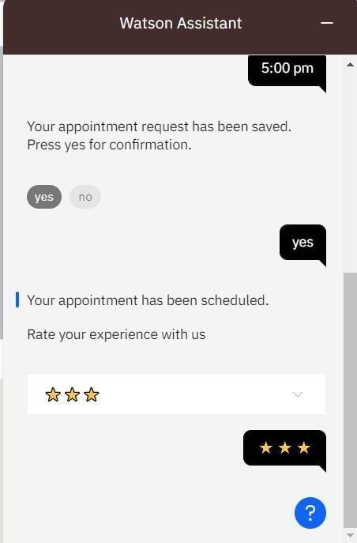

# Question 5:

Create Watson assistant service with 10 steps and use 3 conditions in it. Load that script in HTML page.

Script in HTML page:

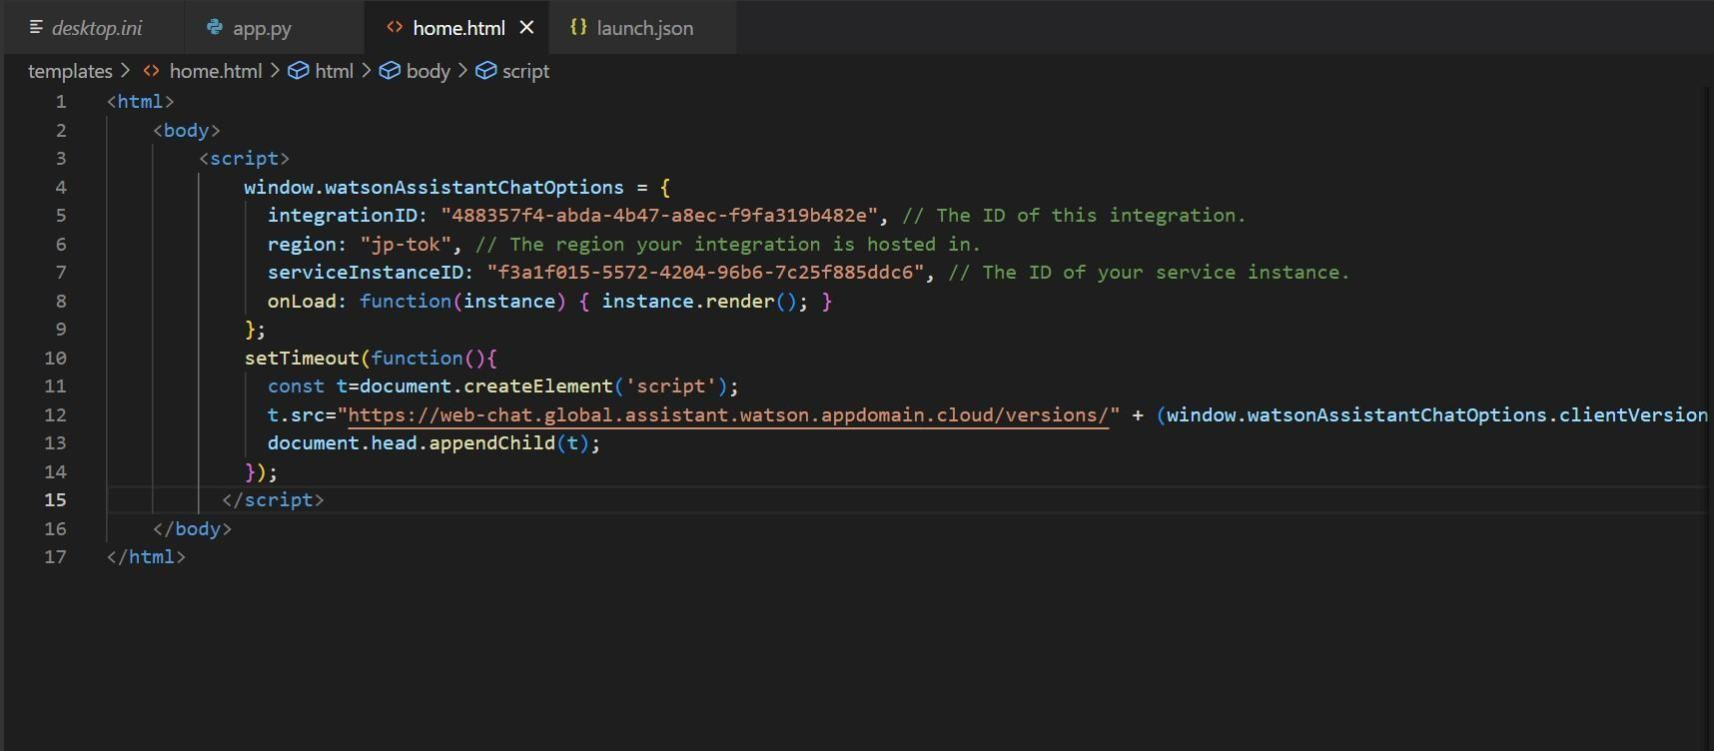

Food-ordering bot:

## Watson Assistant —

Welcome, how clan I assist you?



### Select the food item







Watson Assistant —

## For delivery we yvill need a few pieces of information. Let me guide you through this process!

#### First, please provide your first name.



Thanks! Now, enter your last name.



Awesome. I’llatso need an email address associated with your new account. We will send you the delivery details to your email

Which email address would you like to use?



Watson Assistant —

## Enter the delivery location



We need your i›hone nunbcr to contact you. Would you like to do so?

#### Yes, I'd like to add a phone numbers



O kay, please ente r your phone number below.



Watson Assistant —

Please enter a vahd who ne nrim bei.



T hands! Docs the folloWi ng information look correct? If so, I Will proceed a•itI1 placing your order

* Name: Var unAru n
* Email Address: ‹zrri nv ar u n •maiI.com
* Phone Number: 6482973043
* Delivery Location: 12 th Street Manali

IU WtO W II



## Watson Assistant —

### Email Address: ai”u nvñLLIf1 gn1‹ail.com “

* Phone Number: 6482973043
* Delivery Location: 12 th Street Manali

I1C WtO W II



#### Your order will be uclivcred withi n 3 0 mins ! You will receive an cmai I cont rmation shortly.

We SCO 0!